TensorFlow
TensorFlow is a popular framework of machine learning and deep learning. It is a free and open-source library which is released on 9 November 2015 and developed by Google Brain Team. It is entirely based on Python programming language and use for numerical computation and data flow, which makes machine learning faster and easier.
TensorFlow can train and run the deep neural networks for image recognition, handwritten digit classification, recurrent neural network, word embedding, natural language processing, video detection, and many more. TensorFlow is run on multiple CPUs or GPUs and also mobile operating systems.
The word TensorFlow is made by two words, i.e., Tensor and Flow
- Tensor is a multidimensional array
- Flow is used to define the flow of data in operation.
TensorFlow is used to define the flow of data in operation on a multidimensional array or Tensor.

Components of TensorFlow:

Tensor
The name TensorFlow is derived from its core framework, "Tensor." A tensor is a vector or a matrix of n-dimensional that represents all type of data. All values in a tensor hold similar data type with a known shape. The shape of the data is the dimension of the matrix or an array.
A tensor can be generated from the input data or the result of a computation. In TensorFlow, all operations are conducted inside a graph. The group is a set of calculation that takes place successively. Each transaction is called an op node are connected.
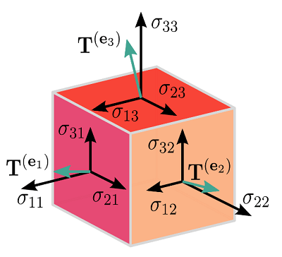

Graphs
TensorFlow makes use of a graph framework. The chart gathers and describes all the computations done during the training.
Consider the following expression a= (b+c)*(c+2)
We can break the functions into components given below:
d=b+c
e=c+2
a=d*e
Now, we can represent these operations graphically below:
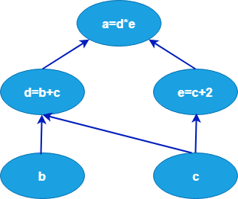

Session
A session can execute the operation from the graph. To feed the graph with the value of a tensor, we need to open a session. Inside a session, we must run an operator to create an output.

Why is TensorFlow popular?
TensorFlow is the better library for all because it is accessible to everyone. TensorFlow library integrates different API to create a scale deep learning architecture like CNN (Convolutional Neural Network) or RNN (Recurrent Neural Network).
TensorFlow is based on graph computation; it can allow the developer to create the construction of the neural network with Tensorboard. This tool helps debug our program. It runs on CPU (Central Processing Unit) and GPU (Graphical Processing Unit).

Use Cases/Applications of TensorFlow
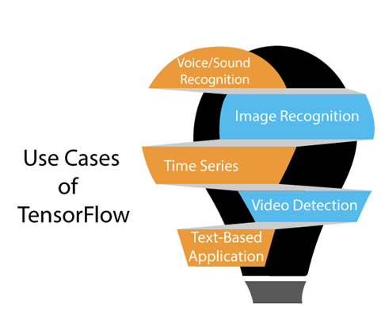
TensorFlow provides amazing functionalities and services when compared to other popular deep learning frameworks. TensorFlow is used to create a large-scale neural network with many layers.

Features of TensorFlow
TensorFlow has an interactive multiplatform programming interface which is scalable and reliable compared to other deep learning libraries which are available.
These features of TensorFlow will tell us about the popularity of TensorFlow.
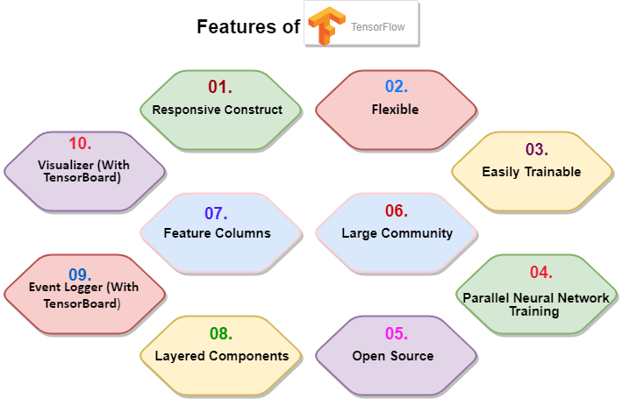

Responsive Construc

We can visualize each part of the graph, which is not an option while using Numpy or SciKit. To develop a deep learning application, firstly, there are two or three components that are required to create a deep learning application and need a programming language.

2. Flexible
It is one of the essential TensorFlow Features according to its operability. It has modularity and parts of it which we want to make standalone.

3. Easily Trainable
It is easily trainable on CPU and for GPU in distributed computing.

4. Parallel Neural Network Training
TensorFlow offers to the pipeline in the sense that we can train multiple neural networks and various GPUs, which makes the models very efficient on large-scale systems.

5. Large Community
Google has developed it, and there already is a large team of software engineers who work on stability improvements continuously.

6. Open Source:
he best thing about the machine learning library is that it is open source so anyone can use it as much as they have internet connectivity. So, people can manipulate the library and come up with a fantastic variety of useful products. And it has become another DIY community which has a massive forum for people getting started with it and those who find it hard to use it.

7. Feature Columns
TensorFlow has feature columns which could be thought of as intermediates between raw data and estimators; accordingly, bridging input data with our model.

Architecture of TensorFlow
The TensorFlow runtime is a cross-platform library. The system architecture which makes this combination of scale flexible. We have basic familiarity with TensorFlow programming concepts such as the computation graph, operations, and sessions.
Some terms need to be understood first to understand TensorFlow architecture. The terms are TensorFlow Servable, servable Streams, TensorFlow Models, Loaders, Sources, Manager, and Core. The term and their functionality in the architecture of TensorFlow are described below.
TensorFlow architecture is appropriate to read and modify the core TensorFlow code.

TensorFlow Servable
- he size of a servable is flexible. A single servable may consist of anything from a lookup table to a unique model in a tuple of interface models. Servable should be of any type and interface, which enabling flexibility and future improvements such as:
These are the central uncompleted units in TensorFlow serving. Servables are the objects that the clients use to perform the computation.
- Streaming results
- Asynchronous modes of operation.
- Experimental APIs

2. Servable Versions
TensorFlow server can handle one or more versions of the servables, over the lifetime of any single server instance. It opens the door for new algorithm configurations, weights, and other data can be loaded over time. They also can enable more than one version of a servable to be charged at a time. They also allow more than one version of a servable to be loaded concurrently, supporting roll-out and experimentation gradually.

3. Servable Streams
A sequence of versions of any servable sorted by increasing version of numbers.

4. TensorFlow Models
A serving represents a model in one or more servables. A machine-learned model includes one or more algorithm and lookup the embedding tables. A servable can also serve like a fraction of a model; for example, an example, a large lookup table be served as many instances.

5. TensorFlow Loaders
Loaders manage a servable's life cycle. The loader API enables common infrastructure which is independent of the specific learning algorithm, data, or product use-cases involved.

6. Sources in TensorFlow Architecture
In simple terms, sources are modules that find and provide servable. Each reference provides zero or more servable streams at a time. For each servable stream, a source supplies only one loader instance for every servable.
Each source also provides zero or more servable streams. For each servable stream, a source supplies only one loader instance and makes available to be loaded.

7. TensorFlow Managers
TensorFlow managers handle the full lifecycle of a Servables, including:
- Loading Servables
- Serving Servables
- Unloading Servables
Manager observes to sources and tracks all versions. The Manager tries to fulfill causes, but it can refuse to load an Aspired version. 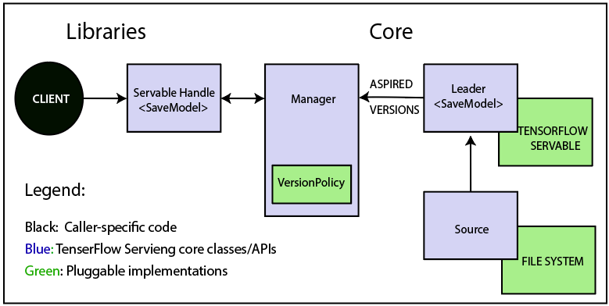
Managers may also postpone an "unload." For example, a manager can wait to unload as far as a newer version completes loading, based on a policy to assure that at least one version is loaded all the times.
For example, GetServableHandle (), for clients to access the loaded servable instances.

